Exhibits Promotion Application

Posted on RETECH official SNS(Blog, Kakao Talk Channel, Facebook,LinkedIn)
and be distributed to relevant departments of municipalities at the end of July
with official paper from Korea Waste Association

1. Applicant Information
Company Name | ZHEJIANG BORETECH ENVIRONMENTAL ENGINEERING CO., LTD.
Manager | Chris Chen | Website | http://www.bo-re-tech.com
Contact | Tel. 0086-573-85120186 | YouTube | https://www.youtube.com/@BORETECH
Exhibits
2. Introducing Exhibits
About Company | BoReTech is a pioneer engineering company in the recycled polyester industry with integrated resources and technology providing total solutions for the plastics recycling system, polyester staple fiber production, textile machine, and bottle-to-bottle plant and service.
Main Product Name | BoReTech PET/PP Tray-to-Tray Recycling System
- Image/photo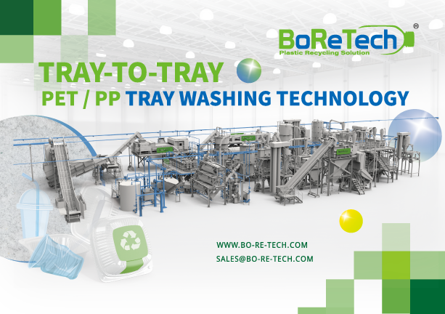
- Specification/Details of Products(1,000)
The ES Process Tray Washing System by BoReTech overcomes bottle necks by delivering four core technological advances, driving process efficiency and innovation in PET and PP tray recycling.
Highly-compacted bales prevent complete material loosening and impurity removal.
Removal challenges of excessive adhesive labels & glue.
Complex material composition,high impurity content.
Low yield rate because of material's brittleness in nature.
PET tray flake quality meets food-grade rPET standards, compliant with FDA & EFSA requirements: Flakes with Adhesive < 2000 ppm; PVC Content < 50ppm
1. Requirement to submit the one high-resolution photo of each exhibit, company/brand logo (ai, jpg format)
2. Submit the company/product/service promotional materials (catalog, brochure, pictures, videos etc.)
3. Please fill out and describe your exhibits as much as you want. There is no limitation on the number of exhibits.

Example image
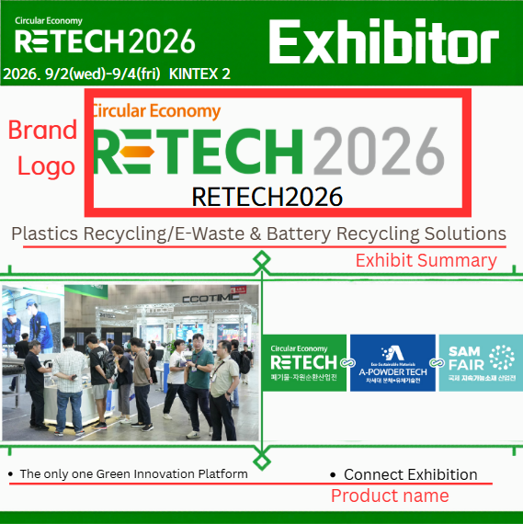
We provide professional editing and promotion services for your products to reach global buyers. Once you submit the required information, we will edit it into an official format as shown below:
This is example from LINKEDIN
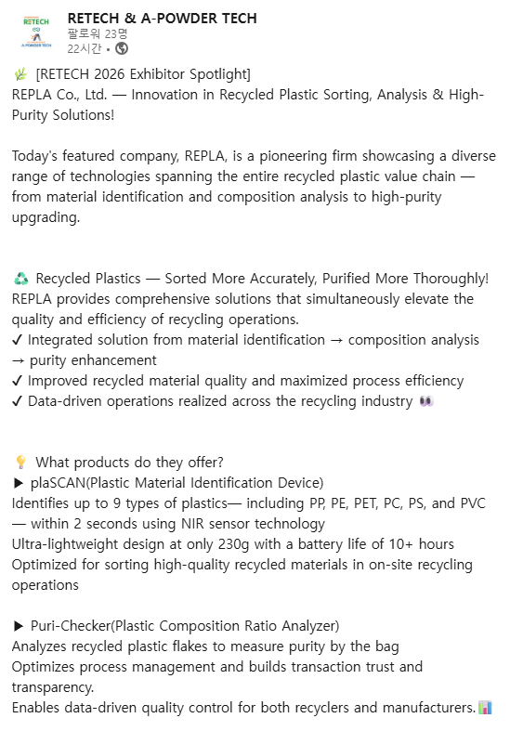 | 